

Odontología

1

**Padecimiento actual**

|  |  |
| --- | --- |
| Si | No |
|  |  |
|  |  |
|  |  |
|  |  |

Cosmetología & Spa

Neuropatías

Implante dental

Cáncer

Convulsiones

Hematológicas

Endocrinas

Mentales

Dermatológicas

|  |  |
| --- | --- |
| Si | No |
|  |  |
|  |  |
|  |  |
|  |  |

Cosmetología & Spa

|  |  |
| --- | --- |
| Si | No |
|  |  |
|  |  |
|  |  |
|  |  |

Cosmetología & Spa

Neurológicas

Metabólicas

Marcapasos

Cardiopatías

|  |  |
| --- | --- |
| Si | No |
|  |  |
|  |  |
|  |  |
|  |  |

Cosmetología & Spa

Cardiovasculares

Pulmonares

Renales

Gastrointestinales

**Antecedentes patológicos**

**Datos personales**

Historia Clínica

Sexo: ___________________

Edad: ___________________

Ciudad: _________________

Escolaridad: _______________

Nombre: ______________________________

Domicilio: _____________________________

Teléfono: _____________________________

Ocupación: _______________________________

FECHA:

EXPEDIENTE:

Otros: _______________________________________________________________________________

ENFERMEDADES DE LA INFANCIA

**Antecedentes no patológicos**

Otros: ___________________

________________________

Ejercicio: ________________

|  |  |
| --- | --- |
| Si | No |
|  |  |
|  |  |

Cosmetología & Spa

|  |  |
| --- | --- |
| Si | No |
|  |  |
|  |  |

Cosmetología & Spa

|  |  |
| --- | --- |
| Si | No |
|  |  |
|  |  |

Cosmetología & Spa

Tabaquismo

Alcoholismo

Traumatismo

Cirugías

Toxicomanías

Sedentarismo

Motivo de consulta:

**Examen clínico extra oral**

Cabeza: _____________________________________________________________________________________

Cara: _______________________________________________________________________________________

ATM: _______________________________________________________________________________________

Ganglios: ____________________________________________________________________________________

Labios: ______________________________________________________________________________________

Señas particulares: ____________________________________________________________________________



2

Odontología

**Examen clínico intra oral**

OBSERVACIONES

Historia Clínica

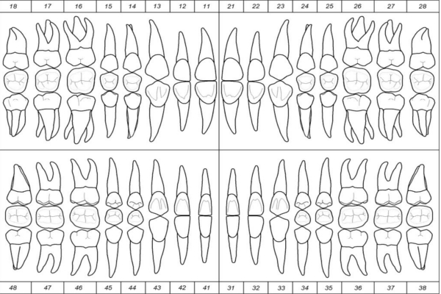

Encía: _____________________________________________________________________________________

Lengua: ___________________________________________________________________________________

Paladar duro: _______________________________________________________________________________

Paladar blando: _____________________________________________________________________________

Faringe: ___________________________________________________________________________________

Piso de la boca: _____________________________________________________________________________

Reborde residual: ___________________________________________________________________________

Tipo de oclusión: ____________________________________________________________________________

Yo___________________________________________ hago constar que la información proporcionada es verídica y autorizo que se me realicen los procedimientos correspondientes para mi tratamiento o plan de trabajo aunque conozco los riesgos que los procedimientos conlleven.

TRATAMIENTO:

DIAGNÓSTICO:

Nombre y firma del profesional

Nombre y firma padre o tutor

Nombre y firma del paciente